Fitness Trainer UI

1. We have installed Node.js and its packages.
2. Then we will install Material UI.
3. After successfully setting up this into VS code, we will write our code in React.
4. I wrote my code in SRC>component>clients.
5. Then imported it into App.js

Adding Appointments:

Here I have created component for adding appointments and also attached its css file

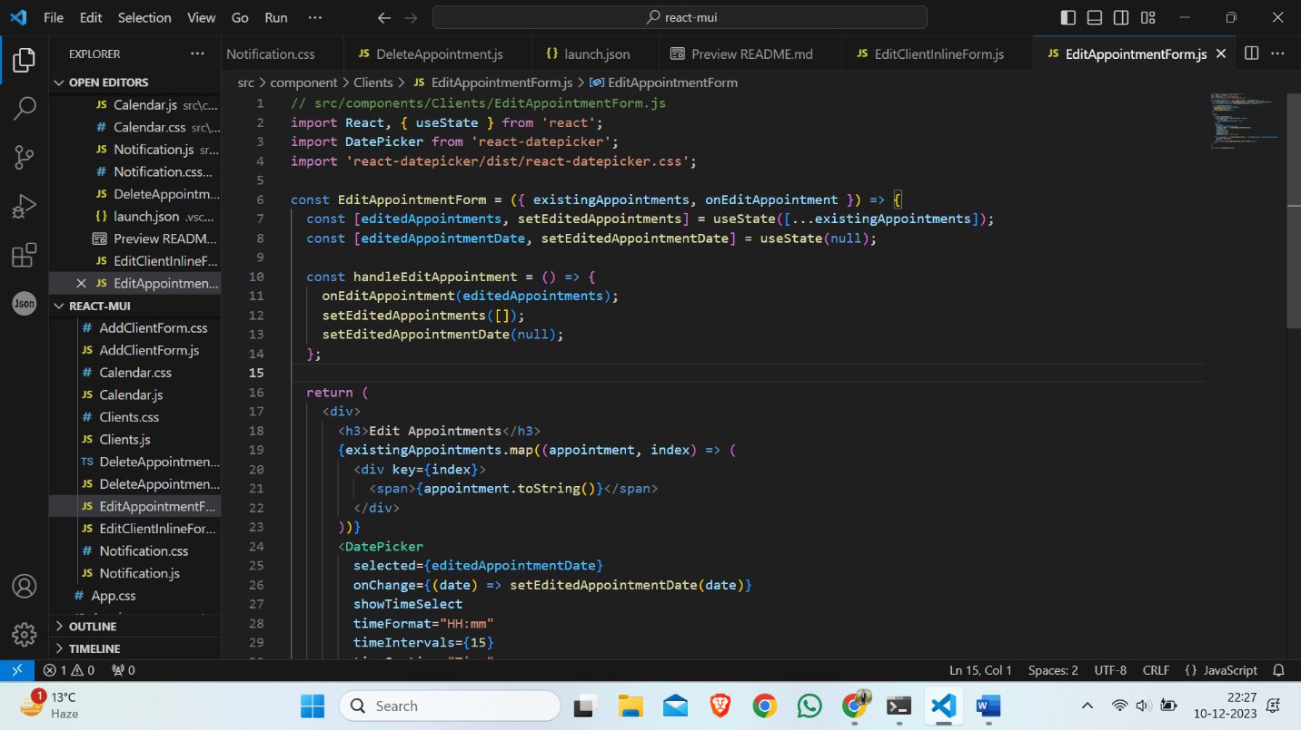

Editing Appointments:

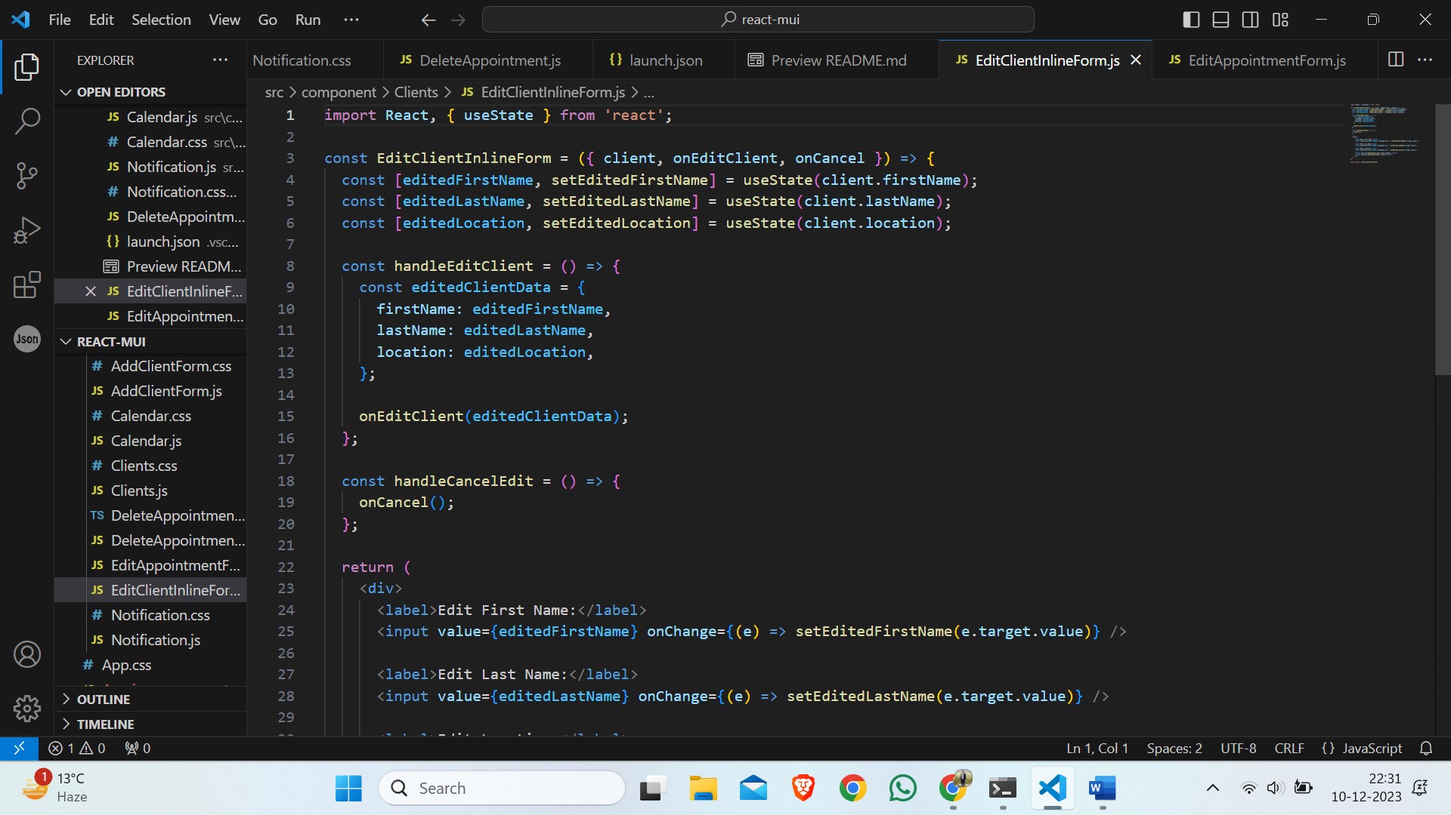Here is the component for editing appointments

Deleting Appointment:

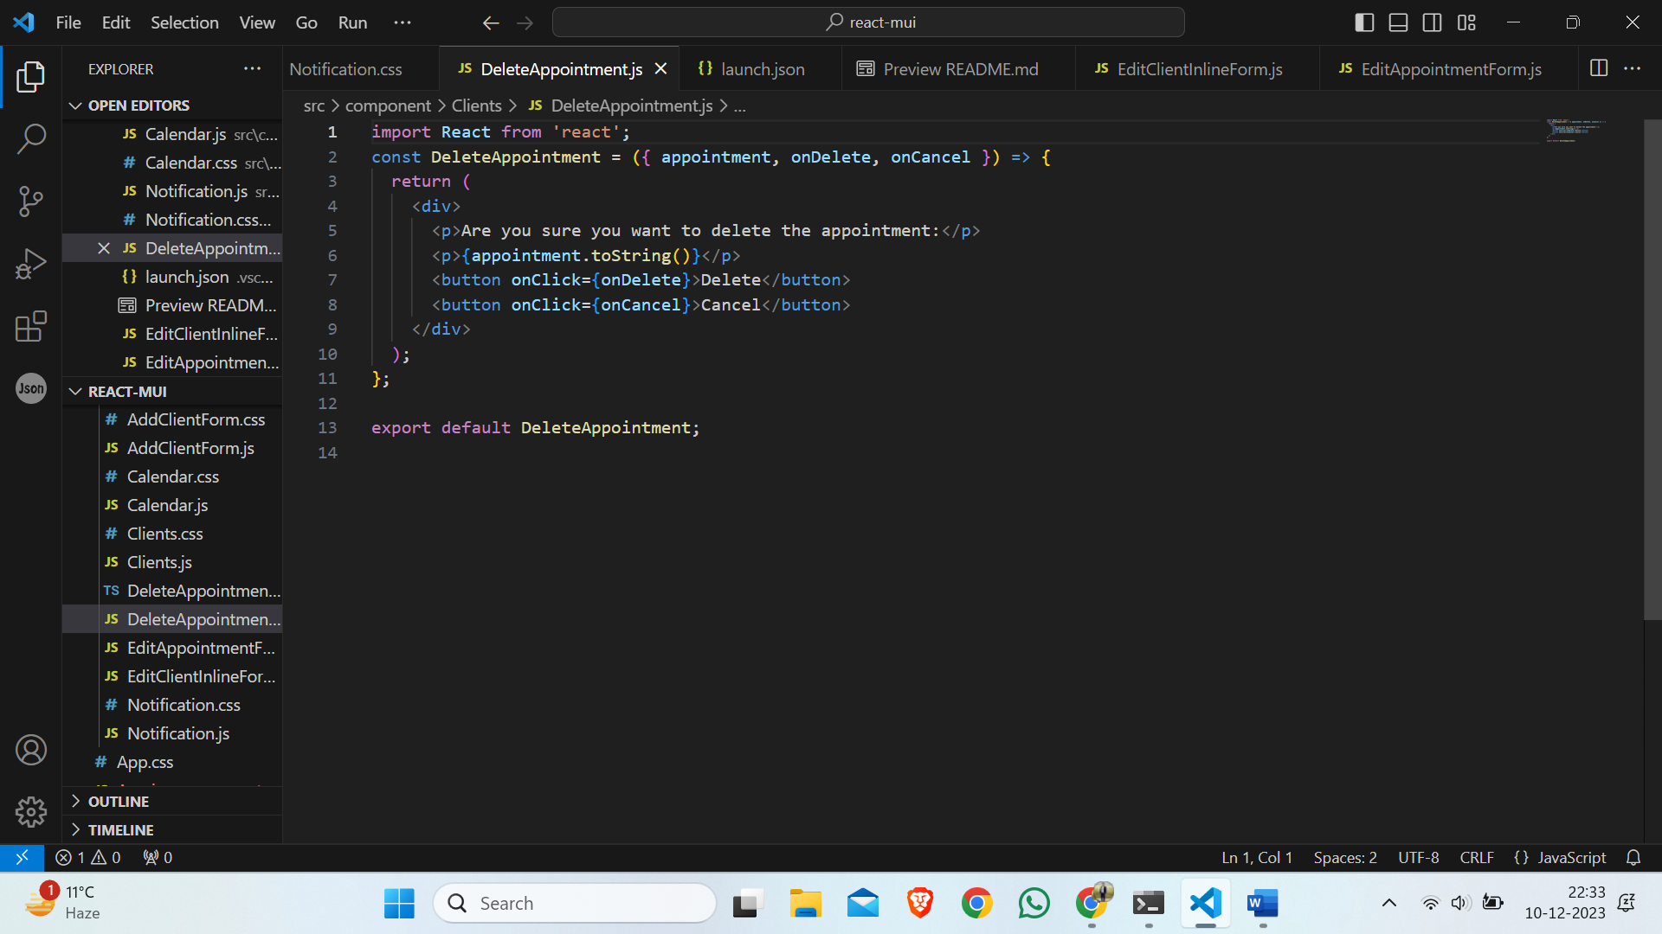Here I have created component for deleting the appointment.

Appointments Notification:

Here I have created a component for appointments Notification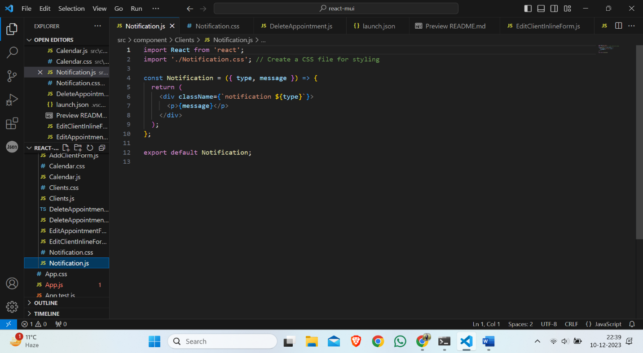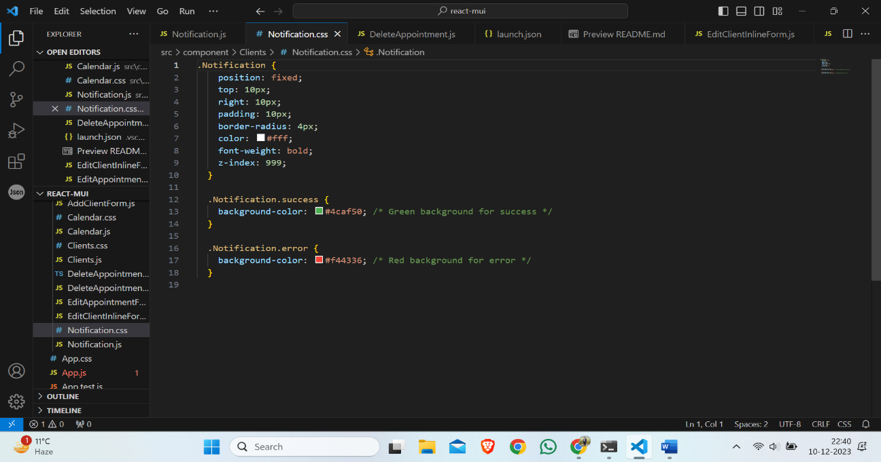

Calendar:

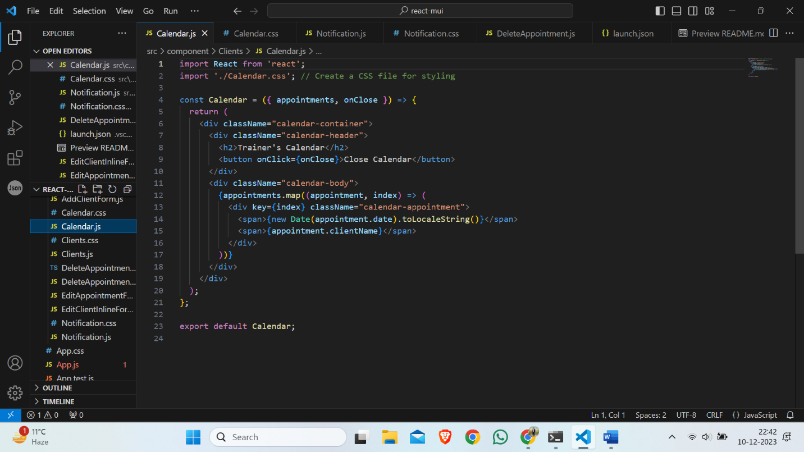

CSS file:

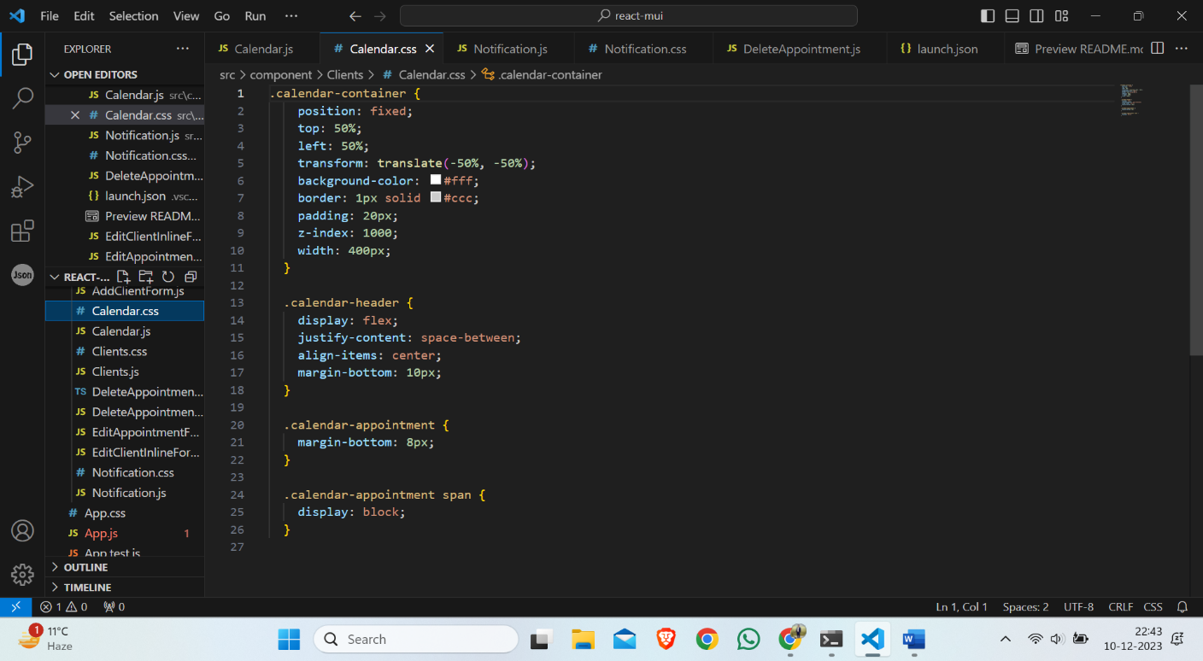

Program compiled successfully: